How does the Number of Coils of an Electromagnet Affect the Mass of Staples Attracted?

# Introduction

Electromagnets are ubiquitous in modern society. Electromagnets are used in scrapyards to find valuable steel and iron, and in computers’ hard drives where they magnetize the disk to output information. Most interesting is that electromagnets are found in electric motors, where the induction of current for force is provided by iron-core electromagnets. These processes power a great part of the modern technological world. (Williams, 2016)

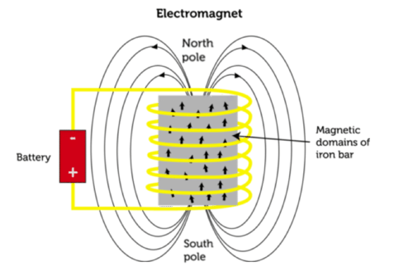An electromagnet operates by coiling a current-carrying wire. The current as it flows through the wire creates a strong magnetic field due to the coils all pointing the magnetic field together. The magnetic field’s strength can be increased when the wire is coiled around a core ferromagnetic material, as when the wire is charged, the electrons of the material are aligned around the magnetic field and are now in motion. As the atoms of the core material move unidirectionally, the magnetic field strength is increased. This ability to amplify the magnetic field strength of a core material while in air is denoted as its relative permeability. (Nave, Ferromagnetism, 2016)

**Figure 1:** Image illustrating the how a battery creates a magnetic field through an iron bar, orientating its magnetic domains (cK-12, 2020)

Three other factors also increase the magnetic field strength of an electromagnet: current strength, the number of coils, and the coils’ proximity to the core. As magnetic field strength is proportional to the motion of the particles, an increase in the current strength must increase the magnetic field strength. The number of coils as well would increase magnetic field strength as it’s the charge in the wire that generates a magnetic field. Therein, an increase in number of coils necessitates an increase in magnetic point sources which would increase overall magnetic field strength. Lastly, as the wire is closer to the metal, there would be a stronger magnetic field operating on the metal, therein increasing its atom’s motion amplifying the magnetic field strength. (Nave, Ampere's Law, 2016)

Therein, between the coiling of an electromagnet and its magnetic field strength, one wonders:

How does the number of coils of an electromagnet affect the mass of staples attracted?

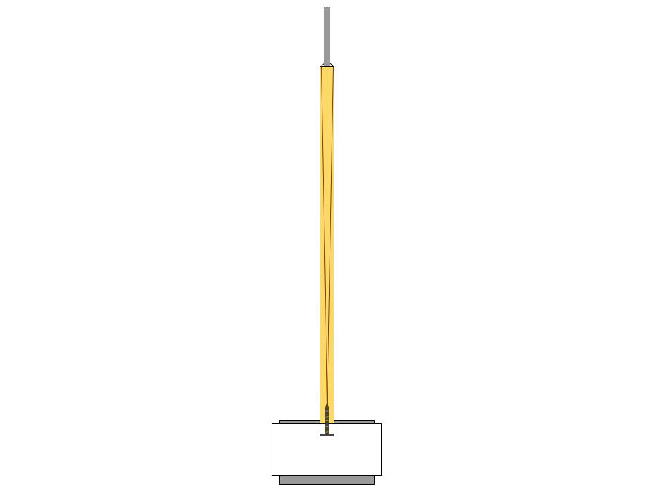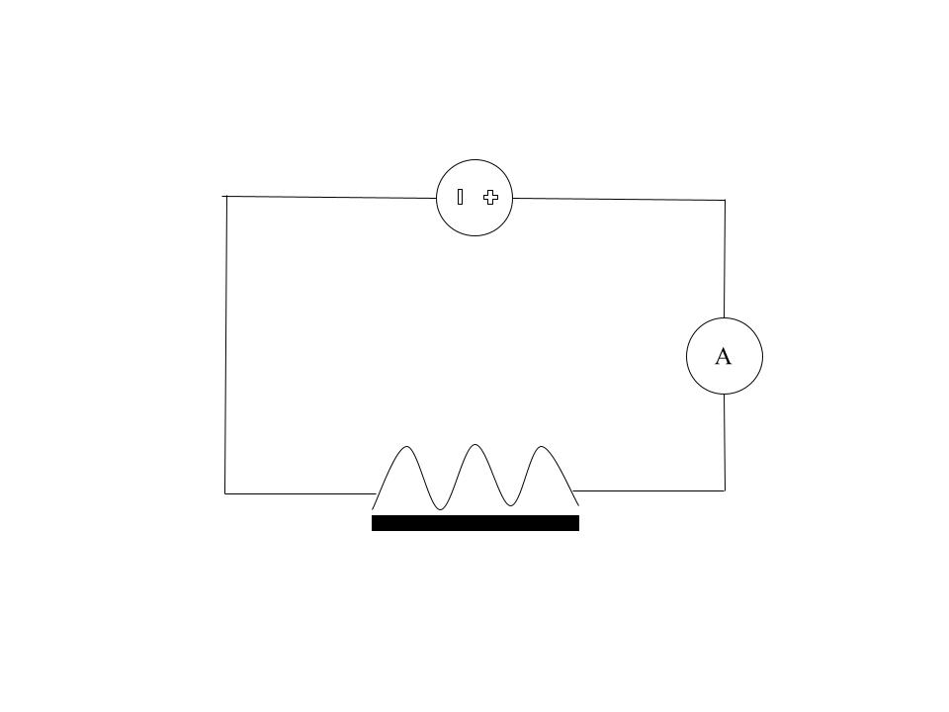For this experiment, a series circuit with a DC power supply and an ammeter will be used. The series circuit is optimal in that one can measure a consistent current throughout the circuit, and as well with only one electromagnet it minimizes wires usage and thus potential errors. A DC power supply and an ammeter will be used to maintain a constant current. The DC power supply has a configurable current setting, and thus measured with an ammeter can escape the errors of current dropping in a battery. The current will thus be fixed at 2 amperes as higher levels of current may overheat the wiring. The wire used in this lab will be an insulated wire with clamp between the DC power supply and the ammeter, and from the copper wire to the DC power supply. This is for safety and error, as the DC power supply potentially can output too high current or voltage and thus may be unsafe with copper wiring, and furthermore clamping is tight and thus the circuit can be more reliably completed. 50cm of copper wiring will be used as it is readily available and is easy to bend, thus a perfect coil material for a classroom electromagnet experiment. An iron nail will as well be used as the ferromagnetic core due to its ready availability, and as well to reflect the real world as iron nails are quite abundant in use everywhere.

**Figure 2**: A circuit diagram of the experimental set-up with a DC power supply and an ammeter connected in series with a resistor that is the electromagnet.

An iron nail has a relative permeability of 5000 (Engineering Toolbox, 2016), and combined with the fact that the staples only weight $0.02g$, the range of the number of coils do not have to be very large. Thus, along with the fact that the iron nail is $8cm$ long, and that the copper wiring is $50cm$ long, the range for this experiment has been determined to be optimal at $30-100$ coils. Wiring after 100 coils would overlay coils on top of each other, introducing another source of error from the proximity to the nail, whilst having under 30 coils produces a negligible magnetic field.

The last key considerations for the experiment are the need for a ruler-pulley system and a paper base. The ruler-pulley system, akin to a magnetic crane, is needed as due to the electromagnet possessing a charge from the copper wiring, the staples may too be charged upon contact, thus attracting more staples. Therein, a ruler-pulley system is needed for a consistent angle on contact with the staples to minimize the random error of charging the staples, and to pull the electromagnet up in a consistent way and to a consistent level such that only staples attracted to the electromagnet itself remain. The paper base is necessary in that the electricity from the copper wire may charge the stand the staples rest on, thus attracting the staples. Thus an insulated surface of a paper base is required to rest the staples on top of.

**Figure 3**: Ruler taped onto retort stand and a string coiled from behind retort stand tied to electromagnet in front. Also displayed is the paper base.

# Research Question, Overview, Variables

## Research Question

How does the number of coils of an electromagnet affect the mass of staples attracted?

## Hypothesis

One would hypothesize a positive linear correlation between number of coils and mass of staples attracted because as number of coils increase, the magnetic field would also increase, stipulating that an increase in the mass of staples attracted

## Variables

|  |  |  |
| --- | --- | --- |
| Independent Variable | Range | Approach |
| Number of Coils | 30 – 100 coils | Will be measured by counting the number of coils on one side of the nail. |

|  |  |
| --- | --- |
| Dependent Variables | Approach |
| Grams of Staples Attracted | The grams of staples will be measured by moving the staples attracted onto an electronic scale. |

|  |  |  |
| --- | --- | --- |
| Control Variable | Approach and Reasoning | Measurement |
| Current Travelling through Wire – 2 Amps | Will affect the magnetic field strength due to current increasing | Current strength will be fixed at 2 amperes and will be confirmed using an ammeter. |
| Coil Proximity to Nail – Coiled on Nail | Closer coiling to the nail will allow a greater effect of relative permeability on magnetic field. | Will be maintained by coiling the wire directly on the nail in a solenoidal pattern. |
| Relative Permeability – $$200$$ | Will drastically increase or decrease the power of the magnetic field due to the differing number of flux lines. | In this case it is ferromagnetic iron, and this iron nail will be utilized throughout the experiment. |
| Length of the Iron Nail – 8cm | The number of turns of the wire of the electromagnet is what determines the magnetic field strength of an electromagnet. | Will be measured beforehand and the original core material (iron nail) will be kept and used throughout the experiment. |
| Angle Hitting the Pile of Staples | Depending on the angle hitting the pile, the magnetic force may be weaker as there are fewer staples to attract. | The creation of the ruler-pulley system constrains the electromagnet’s movement and allow the electromagnet to lower to only one spot. |
| Charging and Mutual Attraction of Staples | As electricity moves through the staples, they gain a magnetic charge and thus attract one another, not truly attracting to the electromagnet. | Using the ruler-pulley system to pulley the electromagnet up will maintain that only staples attracted to the electromagnet itself stays on. |
| Distribution of the Staples | Heterogeneity of the staples will affect the mass of staples attracted in the range of the magnetic force. | Shaking the paper base every trial will maintain that the staples are distrusted evenly in a select area on the paper. |

# Methodology

## Equipment

|  |  |
| --- | --- |
| **Materials** | **Specifications** |
| 1x Iron Nail | 80g net mass. |
| 50cm of Copper Electrical Wiring | — |
| Direct Current Power Supply | Able to output 2 Amperes. |
| 3x 10cm Silicon Wires with Clamps | Must be insulated and able to attach to power supply. |
| 1x Paper Sheet | Must be able to insulate electricity |
| Ruler | Must be able to measure up to 50cm. Reading uncertainty of $±5mm$. |
| 1x String | 1 meter long and strong enough to carry electromagnet. |
| 50x Steel Staplers | 0.02g net mass |
| 1x Retort Stand | — |
| 1x Ammeter | Able to measure up to 2 Amperes. Reading uncertainty of 0.1A. |
| 1x Electronic Scale | Able to measure up to 5 grams. Wind shield to protect against disturbances from the air. Reading uncertainty of 0.001g. |

## Safety and Environmental Factors

* As one is dealing with electrical equipment, take care of potential dangers.
  + One should preferably be wearing electrical gloves.
  + Working on an insulated surface is necessary for grounding.
* As one is working with a magnetic field, other equipment possibly conducive to a magnetic field should be put away in case of accidental attraction.
* The iron nail may be dangerous if handled haphazardly due to its sharp edge.
* Discharges and overheating may occur when handling the electrical wiring and the DC power supply. Consult supervisors and equipment information sheet on safety precautions and dangers before using equipment.
* The electricity that is used within the experiment may have come from environmentally harmful or unethical sources, such as petrochemical plants or from the displacement of natural animal habitats. Read up on local bylaw, county, or provincial energy fact sheets to see if the energy used in your lab is sustainable and ethical.

## Procedure

1. Tape a ruler stick upright onto a retort stand such like **Figure 3**.
2. Place a piece of paper on the bottom of the stand, then place the 50x steel staples on top of the paper base. The steel stapler should be homogenously distributed over the piece of paper.
3. With an iron nail and the $50cm$ of copper wiring, coil the copper wiring onto the iron nail thirty times. Make sure each coil is directly next to each other.
4. With the insulated wires and alligator clamps, attach the DC power supply to the ammeter. Then clamp the ammeter to one end of the copper wiring. Then clamp the other end of the copper wiring back to the DC power supply.
5. Loop a string at the top of the ruler around from behind the retort stand. Then tie the string onto the iron nail. The iron nail should just barely be touching the ground whilst hanging from the string. Make sure it is a tight fit. One should be able to lift the nail from the string.
6. With the iron nail resting amidst the steel staplers, twist the DC power supply amperes nob to 2 amperes. Confirm that the current is at 2 amperes on the ammeter.
7. Pull on end of the string to pull the electromagnet up. Pull the electromagnet up $40cm$.
8. Transfer the attracted steel staplers onto the electronic scale.
9. Turn off the DC power supply.
10. Obtain a reading for the grams of staples on the electronic scale. Then return the steel staplers back into the pile of staples on the paper base.
11. With all the steel staplers returned onto the paper base, shake the paper base for a homogenous distribution of steel staplers on the paper once more.
12. Repeat **Steps 6-11** 20 times for 20 data points.
13. Upon completing **Step 12** and obtaining 20 data points, add ten more coils onto the electromagnet.
14. Repeat **Steps 6-13** 6 more times increasing the number of coils on the electromagnet in intervals of 10 until 100 coils and 7 sets of 20 data points.

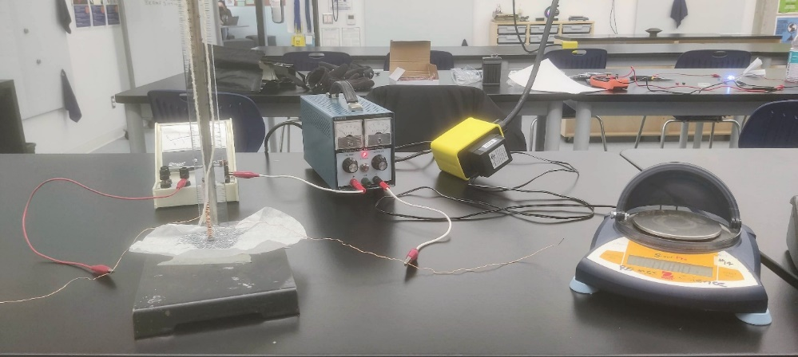

Electronic Scale

Wire and Clamp

Paper Base

Nail with Copper Wiring

Ammeter

DC Power Supply

Ruler and String

***Figure 4:*** *Photograph of Experimental Set-up*

# Data Analysis

## Relevant Qualitative Data

|  |  |  |  |  |  |  |  |  |
| --- | --- | --- | --- | --- | --- | --- | --- | --- |
| **Trials** | $$30N$$ | $$40N$$ | $$50N$$ | $$60N$$ | $$70N$$ | $$80N$$ | $$90N$$ | $$100N$$ |
| $$1-5$$ | Only 1 or 2 spokes are forming upon attraction. Spokes are not long, only being 2-3 staples. Also interstaple force not strong. |  | After coiling 10 more coils, must reclamp to copper wire as copper wire too short and circuit breaks. Clamps do not bite down hard | DC Power Supply’s current strength is slowly decreasing. Must be recalibrated after conducting a couple trails. |  |  | Nail beginning to angle itself upon pulleying as the copper wire becomes shorter. Affects nail as nails now attract on a tilted head. | Must spend a while moving the wires and clamps as clamping faulty with short copper wiring. Super hard as wire very short. |
| $$5-10$$ |  | The base of the retort stand has begun attracting staples when one returns the staples from the electronic scale back into the staple pile. |  | Quite a few spokes are forming now of 4-6 staples long. Staples at end of spoke fall off upon pulleying the nail up. |  | Upon attracting staples, a hole is now left in the steel staplers’ pile. Such is the strength of the attraction and now must frequently mix. | Several spokes have formed upon attraction, spokes are very long extending to 7 staples and are quite strong, often end staple not falling. |  |
| $$10-15$$ | Upon returning the staples back to the pile, the staples pile up on top of one another, sometimes clumping together. | Staples have begun attracting to other staples while in the pile. This has noticeably increased the clumping. | Piling of staples seems to increase as number of coils on the nail increases. Staples seem to stick to each other now. | Some steel staplers get stuck under the grooves of the electronic scale. Difficult to see but seems to have no effect on weighing. | Must shake the steel staplers after each trial to prevent clumping of staplers. Hard to keep mixture homogenous after attracting | Pulleying the electromagnet up sometimes disconnects the circuit due to copper wire movement. Takes while to reconnect. |  | Lots of staples attracted to electromagnet, difficult to transfer to electronic scale, circuit breaks very often while transferring. |
| $$15-20$$ | The nail upon being lifted by the pullet hits the ruler and may damage attraction of the nails, cause staples to fall. | Difficulties with the clamping of the wires is stopping trials. The circuit suddenly stops, fall off or isn’t tight enough. |  |  | Wire clamping quite hard to keep on, wire is too short and is affecting nail hitting on ruler and potentially loosening nails. | Contact with pile difficult to keep constant as copper wire becomes short, clamps beginning to pull on nail. | Mutual attraction between staples now noticeable, large clumping of staples on the paper base and is hard to divide |  |

## Quantitative Analysis

### Raw Data

***Mass of Staples Attracted Raw Data in Grams $(m)$***

|  |  |  |  |  |  |  |  |  |
| --- | --- | --- | --- | --- | --- | --- | --- | --- |
| **Trial (n)** | $$30N$$ | $$40N$$ | $$50N$$ | $$60N$$ | $$70N$$ | $$80N$$ | $$90N$$ | $$100N$$ |
| 1 | 0.083 | 0.175 | 0.453 | 0.578 | 0.858 | 1.690 | 2.889 | 2.831 |
| 2 | 0.011 | 0.085 | 0.253 | 0.421 | 1.448 | 2.209 | 1.151 | 2.831 |
| 3 | 0.021 | 0.226 | 0.328 | 0.588 | 1.281 | 1.921 | 1.644 | 1.605 |
| 4 | 0.022 | 0.144 | 0.243 | 0.627 | 1.072 | 1.426 | 1.360 | 2.270 |
| 5 | 0.046 | 0.169 | 0.262 | 0.321 | 1.285 | 1.798 | 1.561 | 3.082 |
| 6 | 0.024 | 0.129 | 0.300 | 0.414 | 1.283 | 2.007 | 1.279 | 2.528 |
| 7 | 0.062 | 0.071 | 0.130 | 0.323 | 0.970 | 1.005 | 1.765 | 1.843 |
| 8 | 0.022 | 0.096 | 0.141 | 0.584 | 1.022 | 1.347 | 1.953 | 2.064 |
| 9 | 0.044 | 0.086 | 0.259 | 0.437 | 1.196 | 1.581 | 1.952 | 1.728 |
| 10 | 0.032 | 0.035 | 0.428 | 0.475 | 1.390 | 1.476 | 1.310 | 1.762 |
| 11 | 0.024 | 0.230 | 0.347 | 0.418 | 0.988 | 1.610 | 1.946 | 1.230 |
| 12 | 0.048 | 0.153 | 0.308 | 0.839 | 1.089 | 1.822 | 1.904 | 2.856 |
| 13 | 0.038 | 0.096 | 0.370 | 0.415 | 1.226 | 1.821 | 1.898 | 2.568 |
| 14 | 0.028 | 0.112 | 0.156 | 0.645 | 1.748 | 1.934 | 1.309 | 2.437 |
| 15 | 0.016 | 0.039 | 0.276 | 0.611 | 1.040 | 1.585 | 1.207 | 2.652 |
| 16 | 0.025 | 0.035 | 0.336 | 0.475 | 1.228 | 1.367 | 1.418 | 1.633 |
| 17 | 0.022 | 0.029 | 0.243 | 0.691 | 1.498 | 1.496 | 1.931 | 1.416 |
| 18 | 0.022 | 0.076 | 0.346 | 0.669 | 1.130 | 1.493 | 1.668 | 3.028 |
| 19 | 0.032 | 0.122 | 0.299 | 1.048 | 1.181 | 1.364 | 1.509 | 1.962 |
| 20 | 0.022 | 0.074 | 0.384 | 0.632 | 1.275 | 1.551 | 1.985 | 2.044 |

***Table 1:*** *Table showing the raw data of the grams of staples measured on the electronic scale ordered by trial conducted and number of coils [Mass to Thousandth Gram]*

### Calculating Average Mass of Staples Attracted

The average mass of staples attracted is calculated by find the mean of the dataset. The equation is:

$$\overline{m}=\frac{\sum{m}}{n}$$

For example, using 30 coils ($N$) from **Table 1** and a total number of trials of 20:

$$\overline{m}=\frac{0.083+0.011+0.021+…+0.022}{20}=0.032g$$

### Calculating Uncertainty

Uncertainty can be calculated by finding the standard deviation of each dataset. The equation is:

$$σ=\sqrt{\frac{\sum{{\left(m-\overline{m}\right)}^{2}}}{n}}$$

Calculating again using 30 coils from **Table 1**:

$$σ_{30N}=\sqrt{\frac{{\left(0.083-0.032\right)}^{2}+{\left(0.011-0.032\right)}^{2}+{\left(0.021-0.032\right)}^{2}+…+{\left(0.022-0.032\right)}^{2}}{20}}=±0.017g$$

Thus, adding the measurement uncertainty of $0.001g$ from the electronic scale:

$$Error=±0.017±0.001=±0.018g$$

### Processed Data

***Mass of Staples Attracted Processed Data $(g)$***

|  |  |  |
| --- | --- | --- |
| **Number of Coils(N)** | **Average Mass** | **Error** |
| 30 | 3.22E-02 | 1.78E-02 |
| 40 | 1.09E-01 | 5.91E-02 |
| 50 | 2.93E-01 | 8.60E-02 |
| 60 | 5.61E-01 | 1.73E-01 |
| 70 | 1.21E+00 | 2.03E-01 |
| 80 | 1.63E+00 | 2.73E-01 |
| 90 | 1.68E+00 | 3.94E-01 |
| 100 | 2.22E+00 | 5.52E-01 |

***Table 2:*** *Table showing the mean mass of staples attracted and standard deviation of each dataset of* ***Table 1*** *[Mean Mass and Standard Deviation in 3 s.f.]*

## Graphical Analysis Using Excel 2022

***Graph 1:*** *Graph of the number of coils vs. the average mass of staples attracted measured on the electronic scale. [Mass in 3 s.f.]*

***Graph 2:*** *Graph of the normal distribution of the masses of staples attracted of the dataset of 30 coils. See appendix for individual normal distributions in* ***Graphs 3-10.*** *[Mass in 3 s.f.]*

# Conclusion

In concluding, the data in the experiment proposes a strong positive linear correlation between the number of coils of an electromagnet and the mass of staplers it attracts.

Therefore, the hypothesis determined in **§2.2** has been accepted. The precision of the experimental results has been shown to be quite strong, as shown in the high $R^{2}$ value of $0.960$ of **Graph 1**. However, as outlined in **§4.2**, there has been noticeable methodological and random errors prevalent in the experiment, such as the unreliable wires, the clumping of the steel staplers, and the mutual attraction of the charged steel staplers. Moreover, the accuracy of the experimental results has been found to be uncertain, especially in the trendline projecting backwards from $30N$ in **Graph 1**, as well as its y-intercept. Furthermore, the relative uncertainty is also quite high, questioning the precision of the experiment.

Still yet, the conclusions do correlate with the scientific basis in **§1** in that **Graph 1** does illustrate a linear correlation between the increasing of the coils of an electromagnet and the grams of staples attracted. This is in accordance with the theory of electromagnetism: the increased number of coils propagate a stronger magnetic force. However, the y-intercept of **Graph 1** seen in **Table 3** is notably unexpected and worthy of discussion. **Graph 1**’s y-axis is scaled based on the mass of the staples attracted in grams, and thus a negative y-intercept of $-1.19$ would posit that a negative mass is attracted as the number of coils decrease below the x-intercept of $+3.60$. This is impossible, no coils on an electromagnet would eliminate a magnetic force altogether and theoretically must result in a y-intercept of 0. Thus, two possible conclusions may be determined as to the limitations of the experiment. One, variational error in the experimental data from random error could have resulted in the gradient ascertained in experimentation being incorrect, such to fail to extrapolate the trendline to the theoretical y-intercept of zero. However, the LOWFs (Line of Worst Fit) still detail a negative y-intercept, which means that systematic errors may have also contributed, offsetting the graph downwards for a negative y-intercept. Two, the correlation between number of coils and grams of staples may not be linear, such that there begins a plateau at lower ranges of number of coils and then turns into a linear relationship as the range increases. This may be due to the number of coils not being strong enough to orient the magnetic domains of the ferromagnetic core, thus significantly decreasing magnetic strength until there is a sufficient number of coils.

|  |  |  |  |
| --- | --- | --- | --- |
|  | **LOBF** | **LOWF(Min)** | **LOWF(Max)** |
| Gradient | $$+0.0331$$ | $$+0.0228N$$ | $$+0.0456$$ |
| y-intercept | $$-1.19$$ | $$-0.626$$ | $$-1.78$$ |
| x-intercept | $$+36.0$$ | $$+27.5$$ | $$+39$$ |

***Table 3:*** *Table listing the properties of the equations of* ***Graph 1*** *[Figures to 3 s.f.]*

# Evaluation

## Strengths

A great strength of this experiment was that every variable was rigorously controlled. Current is first controlled by a DC power supply, and then independently verified by an ammeter. The angle as to which the electromagnet contacted the staples was restricted a pulley system such to make sure it was consistent every time. The electromagnet’s magnetic force was specifically considered by controlling the height of which the electromagnet was pulleyed up was controlled for, allowing only staples attracted to the electromagnet stayed attached. The mass of the staples was measured on a high-quality electronic scale able to measure to the thousandth decimal place, and then tested again 20 more times. These rigorous methods allowed the experiment a high precision, resulting in a final $R^{2}$ value of $0.960$ and overall a high experimental accuracy.

## Weaknesses

Regarding instrumental error, though the LOBF fits between the LOWFs, the gradient differences of $0.0228N$ from LOWF(Max) to LOWF(Min), a relative difference of $50\%$ suggests low precision in the experimental results. The y-intercepts are as well far apart with a difference of $11.5$ between LOWF(Max) to LOWF(Min), again suggesting low precision. The only direct measurement uncertainty in the experiment is the reading on the electronic scale at $±0.001g$. The impacts of this are generally negligent as masses of staples go up to $2.22g$ as in trials $100N$, equating to a relative uncertainty of $0.05\%$. However, this measurement uncertainty does have a noticeable effect on trials of lower number of coils, like $30N$ with an average of $0.0322g$, equating to a relative uncertainty of $3.1\%$. This variance in relative uncertainties has contributed to the error bars in **Graph 1**, and thusly the differences in LOWFs, impacting experimental precision. A solution to this would be increase the scale of the experiment, from $30N$ to $300N$ to minimize the impact of measurement uncertainty. Another solution would be to use finer measurement equipment. These solutions will decrease the error bars and therein reduce the gradients of the LOWFs of **Graph 1**, increasing precision.

|  |  |  |  |  |  |  |  |  |
| --- | --- | --- | --- | --- | --- | --- | --- | --- |
| Coils | $$30N$$ | $$40N$$ | $$50N$$ | $$60N$$ | $$70N$$ | $$80N$$ | $$90N$$ | $$100N$$ |
| Relative Uncertainty | $$55.3\%$$ | $$54.7\%$$ | $$29.6\%$$ | $$30.8\%$$ | $$16.8\%$$ | $$16.8\%$$ | $$23.5\%$$ | $$24.9\%$$ |

***Table 4:*** *Table listing the relative uncertainties from* ***Table 2****. [Figures to 3 s.f.]*

**Graph 2** and its sublevels **Graphs 3-10** furthermore show that random errors were quite high in experimentation. The largest relative uncertainties occurred in coils $30N$ at $55.3\%$, and the lowest occurred in coils $70N$ at $16.8\%$, as can be seen in **Table 4**. Generally, as the number of coils increased the relative uncertainties decreased. This may be as the quantities of masses increased, the weight of measurement uncertainties and effect of random errors decreased, thus reducing the relative uncertainty. This can be visibly seen in the domains of **Graph 2**.Also notable is that as the number of coils increased, the standard deviations across trials also increased, as from **Table 2 $σ_{30N}=1.78E-02$** to $σ_{100N}=5.52E-01$, and the increasing domains of each line in **Graph 2**. This can be again attributed to the increase in scale: as the number of staples increase the possibility that a methodological error may occur with them likewise increase. Still yet relative uncertainties generally decline as number of coils increase, meaning that overall the experiment was decently controlled for larger scales but lacked for finer measurements. Thus, to improve the experiment one should increase the domain of the experiment, perhaps from $100N$ to $1000N$ to capitalize on the experiment’s effectiveness at large sizes. The extra data with greater precision will therein counteract the low precision of lower coils. Another source of random error may be the unreliable wires in the experiment and the shaking of the staples. First, the wire and clamps often failed whilst in the experiment, causing staples to spontaneously detract from the electromagnet. Often this occurred as the staples were being moved onto the electronic scale, and thus there is a random error as to whether all staples were recovered. A solution to this is simple in hindsight, cup the electromagnet with a bowl when trying to transfer staples to remove the possibility and uncertainty of picking up stray staples. Finally, due to the magnetism and clumping of the staples, one had to shake the paper base every trial to separate the staples. Thus is a random error as to the distribution of the staples across the paper base. Though one tried to shake it to a homogenous distribution, the magnetism of the staples inevitably led to some degree of heterogeneity. The solution for this, as well as the general magnetism will be discussed below. Upon resolving the phenomena in this section, precision will increase as variance decreases, increasing the $R^{2}$ of the experiment and decreasing the size of the error bars. The scaling discussed in response to the high standard deviations will as well contract the domains of the lines of **Graph 2**, lowering the gradient of the trendline of **Graph 1** as outlined in **§5**.

Regarding systematic error, the temporary magnetism from the electromagnet’s magnetic field and electricity has greatly affected the experiment such to result in the discrepancy of y-intercept of $+36$. Even though measures such as ruler-pulley system and shaking the paper base has been instituted to minimize its effect, undoubtably it still exists. Chains coming off the electromagnet as it attracts the staples is one of its effect. These chains come from the electromagnet magnetizing the staples from the stray electricity of the bare electromagnet, therein attracting staples themselves. These chains pull more staples onto the electromagnet, thus increasing the mass measured and shifting **Graph 1** up. **§4.2** further notes that this effect increases as $N$ increases, thus meaning the shift up increases from the left to the right of **Graph 1**, thereby increasing the gradient. Another systemic error is the clumping and mutual attraction of the steel staplers noted in **§4.2.** The clumping of the staples and its mutually attracting means that it is difficult for the electromagnet to attract those staples, thus meaning less mass attracted and shifting **Graph 1** down. The qualitative data in **§4.2** as well notes specifically that the size as well as difficulty to separate these groupings increases as the number of coils increase, indicating that the downwards displacement of **Graph 1** increases as $N$ increases, thereby decreasing the gradient. This phenomenon notably counteracts the shifting up of **Graph 1** of the chaining of the staples, but due to the sheer number of staplers on the base thus affected by the clumping, it produces a greater effect on the experimental data, thereby net shifting **Graph 1** down. Lastly, as the retort stand was also made of metal, it too gained a magnetic potential and began attracting staples as observed in **§4.2**. This effect, though weak in comparison to the two previous phenomena due to the paper base, still decreased the mass of staples attracted to the electromagnet, thus shifting the data of **Graph 1** down. All three errors as well as the need for mixing in the previous segment largely arise from the electricity circulating from the bare electromagnet, and thus one proposes encasing it in an insulating material such as wood to remove the possibility of stray electricity transmitting. As well can one simply wait between each trial for the staples and the stand’s temporary magnetism to wear off. These resolutions should decrease the effects of temporary magnetism, thereby net shifting **Graph 1** up, and negating the increasing effects relative to $N$, therein decreasing the gradient. This is in accordance with **§5**.

## Extensions

Here are some ideas of extensions for future experiments.

* Find the rate of change of the magnetization of the materials upon many trials and currents.
* Number of coils and ability to create temporary magnets and relationship to its mass.
* Broaden the scale of the experiment to thousand of coils and longer electromagnets as outlined in this experiment. Would the correlation still stay positively linear?

Such extensions would allow one greater comprehension of electromagnets and their use in the world, such as the electric motor mentioned in the introduction (**§1**).

# Bibliography

cK-12. (2020, March 24). *4.8 Electromagnet*. Retrieved from cK-12: https://www.ck12.org/book/cbse-physics-book-class-x/section/4.8/

Engineering Toolbox. (2016). *Permeability*. Retrieved from The Engineering Toolbox: https://www.engineeringtoolbox.com/permeability-d_1923.html

Hughes, S. (2005, April 26). *Lecture 19: Displacement Current. Maxwell's Equations.* Retrieved from web.mit.edu: https://web.mit.edu/sahughes/www/8.022/lec19.pdf

Katie Jo Sunday, K. M. (2018). *Effect of Impurities on Aging of Sintered Soft Magnetic Materials.* Cinnaminson: Hoeganaes Corporation.

National Geographic Editors. (2011, January 21). *Magnetism*. Retrieved from National Geographic Encyclopedia: https://www.nationalgeographic.org/encyclopedia/magnetism/

Nave, C. R. (2016). *Ampere's Law*. Retrieved from HyperPhysics: http://hyperphysics.phy-astr.gsu.edu/hbase/magnetic/amplaw.html#c1

Nave, C. R. (2016). *Ferromagnetism*. Retrieved from Hyperphysics: http://hyperphysics.phy-astr.gsu.edu/hbase/Solids/ferro.html#c5

Nave, C. R. (2016). *Hysteresis*. Retrieved from Hyperphysics: http://hyperphysics.phy-astr.gsu.edu/hbase/Solids/hyst.html

Williams, M. (2016, January 13). *What Are The Uses Of Electromagnets?* Retrieved from UniverseToday: https://www.universetoday.com/39295/uses-of-electromagnets/

# Appendices

***Graph 3:*** *Graph of the normal distribution of the masses of staples attracted of the dataset of 30 coils.**[Mass in 3 s.f.]*

***Graph 4:*** *Graph of the normal distribution of the masses of staples attracted of the dataset of 40 coils.**[Mass in 3 s.f.]*

***Graph 5:*** *Graph of the normal distribution of the masses of staples attracted of the dataset of 50 coils.**[Mass in 3 s.f.]*

***Graph 6:*** *Graph of the normal distribution of the masses of staples attracted of the dataset of 60 coils.**[Mass in 3 s.f.]*

***Graph 7:*** *Graph of the normal distribution of the masses of staples attracted of the dataset of 70 coils.**[Mass in 3 s.f.]*

***Graph 8:*** *Graph of the normal distribution of the masses of staples attracted of the dataset of 80 coils.**[Mass in 3 s.f.]*

***Graph 9:*** *Graph of the normal distribution of the masses of staples attracted of the dataset of 90 coils.**[Mass in 3 s.f.]*

***Graph 10:*** *Graph of the normal distribution of the masses of staples attracted of the dataset of 100 coils.**[Mass in 3 s.f.]*